OUNDLE GOLF CLUB DRESS CODE
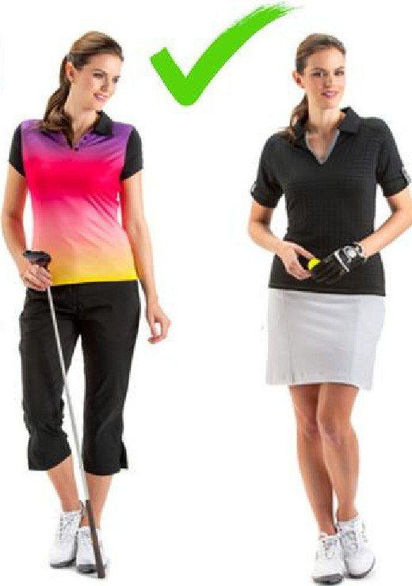
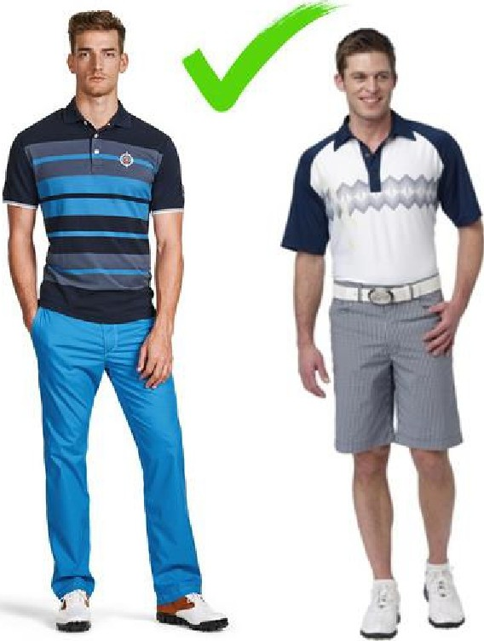
ACCEPTABLE ATTIRE ON THE COURSE
AND PRACTICE FACILITIES

Smart dress is expected at all times.

Tailored shirts specifically designed for golf - collared, collarless, roll necks are acceptable and may be worn tucked in or outside, if specifically designed.

Tailored trousers or tailored shorts / skirt.

Golf shoes - only shoes specifically designed for golf.
Socks - long, ankle or trainer socks.

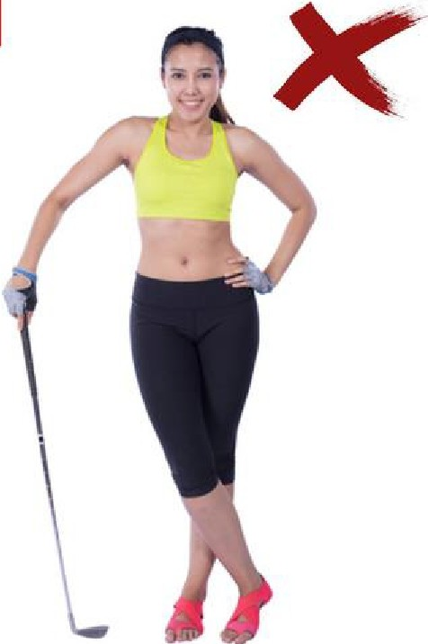
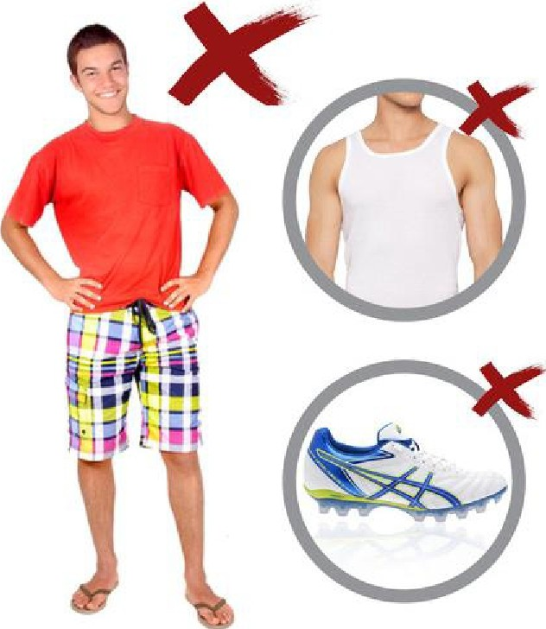
UNACCEPTABLE ATTIRE

T-shirts without collars, singlet tops, cropped or tank tops, or anything that might be considered offensive or untidy.

Brief shorts, beach shorts, cargo shorts,
football or rugby shorts, tracksuits and denim jeans. Street shoes, sandals or bare feet

Sports shoes with studs or deep sole contours that can leave indentations on the greens

In the Clubhouse
No caps or hats, No spiked/cleat golf shoes, No dirty golf shoes, No wet or soiled clothing

Those not complying with the dress code may be requested to leave the course
Oundle Golf Club seeks to promote a friendly, relaxed atmosphere in which members, guests and visitors can enjoy the Course and clubhouse facilities.

