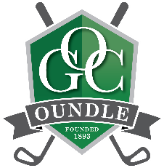

Oundle Golf Club is pleased to announce that it is the first club in the County to sign up to the R&A’s Women in Golf Charter. The national Charter was launched last year to increase the number of women and girls playing golf and to encourage more opportunities for women to work in the game.
Women have always played a vital role at Oundle Golf Club with Veronica Lyon not only chairing the Management Committee but has taken on responsibility for driving this initiative forward and ensuring that women’s golf receives the focus it deserves. Her passion, enthusiasm and commitment to the game will help to build on this strong foundation OGC already has and encourage more women to take up the sport and work in management positions.
“We want to “Get Women into Golf” to ensure our game is not dominated by one group and that our membership is diverse and open to everyone. We want to break down any barriers and preconceptions they may have to the game. We want to demonstrate that golf is an ideal activity that can suit all ages, be played individually and in groups. We want to show that it can be adapted to different abilities, time frames and budgets. As the current lockdown has influenced many people to take up outside exercise we want to continue to build on this positive effect to our advantage and encourage women to take up a different outside exercise”.
The club has a successful golf professional who runs lessons for all levels either individually or in groups. The ladies section is a friendly group who have achieved fantastic success in the Cecil Leitch competition, bringing home the trophy 2 years on the run! They welcome all new female golfers whatever standard they play at offering a buddy system to ensure that the new member feels at home on the course and in the Club.

